**PO1_DGC_Digital Calculator**

**GDD Document**

**Version 1.4**

**Proposed**

|  |  |  |  |  |
| --- | --- | --- | --- | --- |
| **Document Change History** | | | | |
| **Version** | **Author** | **Date** | **Change** | **Status** |
| 1.0 | - Alzahraa Mohamed | 24/1/2020 | * Initial creation | Draft |

|  |  |  |  |  |
| --- | --- | --- | --- | --- |
| **Document Change History** | | | | |
| **Version** | **Author** | **Date** | **Change** | **Status** |
| 1.0 | - Alzahraa Elsallakh | 24/2/2020 | * Initial creation | Draft |
| 1.1 | - Alzahraa Elsallakh | 25/2/2020 | * Adding project Description * Adding software context diagram * Adding input and output signals * Adding software features * Adding static architecture | Proposed |
| 1.2 | - Alzahraa Elsallakh | 27/2/2020 | * Adding output signal to Read Input Control which is “Signal_DisplayedMsg” * Changing the range of signals “Signal_Op1” and “Signal_Op2” from [0.0-999.99] to [0.0 - 9999999] * Changing the unit of signals “Signal_Op1” and “Signal_Op2” from unsigned char to float * Changing the range of “Signal_Operator” from {A…D, *,#} to {A,B,C,D,#} * Changing the output signal of Buzzer Control from “Signal_RunningTone” to “ Signal_RunningFreq” and “ Signal_RunningDuty” * Mapping all previous changes to software feature * Adding Timer component to MCAL layer * Adding “Calculator Interface” to layered architecture * Adding all public API’s to components section | Proposed |
| 1.3 | - Alzahraa Elsallakh | 28/2/2020 | * Moving “Calculator Interface” from “APP” layer to “Service” layer * Updating display signal names * Removing signal “Signal_OnOffState” from “Display Control” * Updating signals’ units * Adding requirement ID’s to all API’s | Proposed |
| 1.4 | - Alzahraa Elsallakh | 14/3/2020 | * Removing “port” as input from API’s related to GPIO in Req_PO1_DGC_GDD_002_V01, Req_PO1_DGC_GDD_003_V01 and Req_PO1_DGC_GDD_004_V01 * Changing state of “covers” fields from NA to the right requirements in Req_PO1_DGC_GDD_002_V01 Req_PO1_DGC_GDD_009_V01, Req_PO1_DGC_GDD_011_V01, Req_PO1_DGC_GDD_016_V01 and Req_PO1_DGC_GDD_018_V01 | Proposed |

|  |  |  |
| --- | --- | --- |
| **Reference Documents** | | |
| **Document Name** | **Version** | **Status** |
| SRS | 1.10 | Proposed |

**Table of Contents**

**1.** **Project Description** 7

**1.1** **Software Context Diagram** 7

**2.** **Input and Output Signals** 8

**2.1** **Activation Control Signals** 8

**2.2** **Read Input Control Signals** 9

**2.3** **Buzzer Control Signals** 10

**2.4** **Do Math Control Signals** 11

**2.5** **Display Control Signals** 12

**3.** **Software Features** 14

**4.** **Static Architecture** 15

**4.1** **Layered Architecture** 15

**5.** **Components** 16

**5.1** **MCAL API’s** 16

**5.1.1** **GPIO** 16

**5.1.2** **Timer** 17

**5.2** **ECUAL API’s** 18

**5.2.1** **KEYPAD** 18

**5.2.2** **LCD** 19

**5.2.3** **SWITCH** 20

**5.2.4** **BUZZER** 21

**5.3** **Application API’s** 21

**5.3.1** **Activation** 21

**5.3.2** **Read Input** 22

**5.3.3** **Buzzer** 22

**5.3.4** **Do Math** 22

**5.3.5** **Display** 23

**Index of Figures**

Figure ‎1‑1 Software Context Diagram 7

Figure ‎2‑1 Activation Control Signals 8

Figure ‎2‑2 Read Input Control Signals 9

Figure ‎2‑3 Buzzer Control Signals 10

Figure ‎2‑4 Do Math Control Signals 11

Figure ‎2‑5 Display Control Signals 12

Figure ‎3‑1 Software Features 13

Figure ‎4‑1 Project Layered Architecture 14

# **Project Description**

This project is a digital calculator that takes input from user and displays the input and the result on a screen.

The hardware used in the calculator is Keypad which takes input from user, LCD to display the result, buzzer to generate tunes on each key press and micro controller that performs all operations in the system.

## **Software Context Diagram**

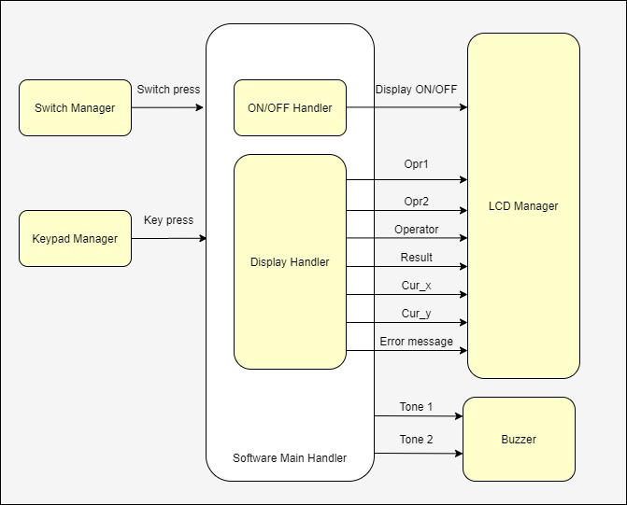

Figure ‑ Software Context Diagram

# **Input and Output Signals**

The input and output signals in the project are listed below in figures, with explained information about each signal.

## **Activation Control Signals**

Input signal: Signal_SwitchPressed

Output signal: Signal_OnOffState

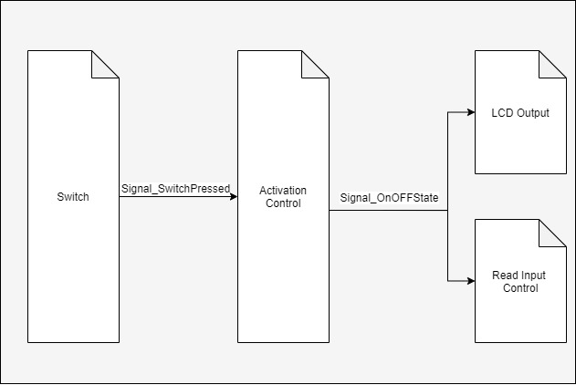

Figure ‑ Activation Control Signals

|  |  |  |  |  |
| --- | --- | --- | --- | --- |
| Signal_SwitchPressed | |  | Signal_OnOffState | |
| Range | [0,1] |  | Range | [0,1] |
| Unit | NA |  | Unit | NA |

## **Read Input Control Signals**

Input signals: Signal_OnOffState, Signal_KeyPressed

Output signal: Signal_Op1, Signal_Op2, Signal_Operator, Signal_Tone, Signal_ErrorMessage

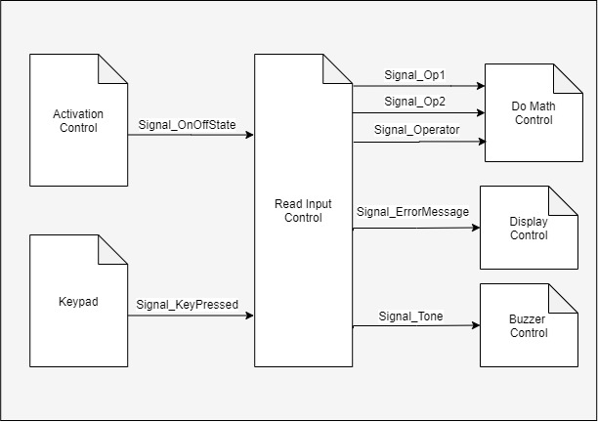

Figure ‑ Read Input Control Signals

|  |  |  |  |  |
| --- | --- | --- | --- | --- |
| Signal_OnOffState | |  | Signal_KeyPressed | |
| Range | [0,1] |  | Range | {0…9, A…D,, #} |
| Unit | NA |  | Unit | NA |

|  |  |  |  |  |
| --- | --- | --- | --- | --- |
| Signal_Op1 | |  | Signal_Op2 | |
| Range | [0.0 – 9999999] |  | Range | [0.0 – 9999999] |
| Unit | NA |  | Unit | NA |

|  |  |  |  |  |
| --- | --- | --- | --- | --- |
| Signal_Operator | |  | Signal_Tone | |
| Range | {A,B,C,D,#} |  | Range | [1,2] |
| Unit | NA |  | Unit | NA |

|  |  |  |  |  |
| --- | --- | --- | --- | --- |
| Signal_ErrorMsg | |  |  | |
| Range | Strings, numbers, operators |  |  |  |
| Unit | NA |  |  |  |

## **Buzzer Control Signals**

Input signals: Signal_Tone

Output signal: Signal_RunningFreq, Signal_RunningDuty

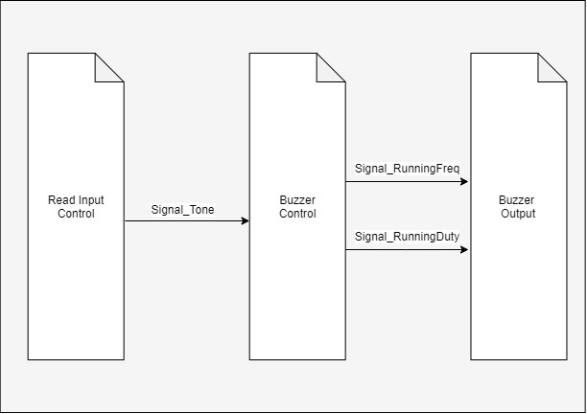

Figure ‑ Buzzer Control Signals

|  |  |  |  |  |
| --- | --- | --- | --- | --- |
| Signal_Tone | |  | Signal_RunningFreq | |
| Range | [1,2] |  | Range | 250, 500 |
| Unit | NA |  | Unit | Hz |

|  |  |  |  |  |
| --- | --- | --- | --- | --- |
| Signal_RunningDuty | |  |  | |
| Range | 50% |  |  |  |
| Unit | NA |  |  |  |

## **Do Math Control Signals**

Input signals: Signal_Op1, Signal_Op2, Signal_Operator

Output signal: Signal_ResultMsg

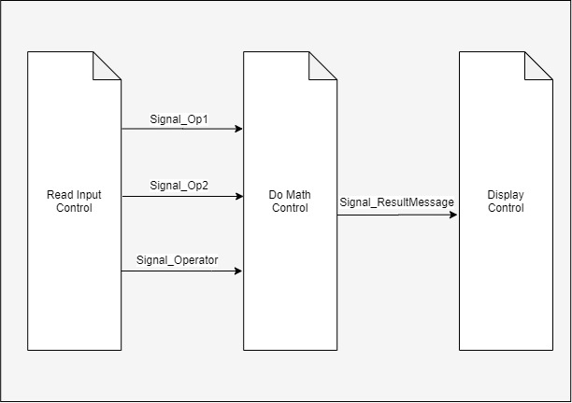

Figure ‑ Do Math Control Signals

|  |  |  |  |  |
| --- | --- | --- | --- | --- |
| Signal_Op1 | |  | Signal_Op2 | |
| Range | [0.0 – 9999999] |  | Range | [0.0 – 9999999] |
| Unit | NA |  | Unit | NA |

|  |  |  |  |  |
| --- | --- | --- | --- | --- |
| Signal_Operator | |  | Signal_ResultMsg | |
| Range | {A,B,C,D,#} |  | Range | Strings, numbers, operators |
| Unit | NA |  | Unit | NA |

## **Display Control Signals**

Input signals: Signal_ ResultMsg, Signal_ ErrorMessage

Output signal: Signal_DisplayedMsg

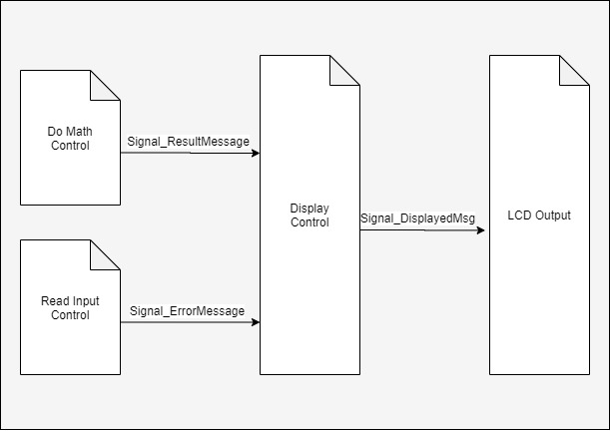

Figure ‑ Display Control Signals

|  |  |  |  |  |
| --- | --- | --- | --- | --- |
| Signal_ ResultMsg | |  | Signal_ErrorMsg | |
| Range | Strings, numbers, operators |  | Range | Strings, numbers, operators |
| Unit | NA |  | Unit | NA |

|  |  |  |  |  |
| --- | --- | --- | --- | --- |
| Signal_DisplayedMsg | |  |  | |
| Range | Strings, numbers, operators |  |  |  |
| Unit | NA |  |  |  |

# **Software Features**

The software features that maps between all software blocks and shows communication between them is shown in Figure ‎3‑1.

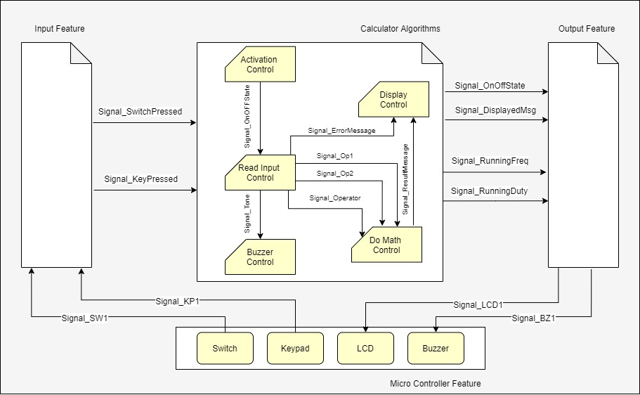

Figure ‑ Software Features

# **Static Architecture**

## **Layered Architecture**

The layered architecture represents the architecture of the project as separate horizontal layers, and shows the dependency of each module in any layer on other modules as shown in Figure ‎4‑1

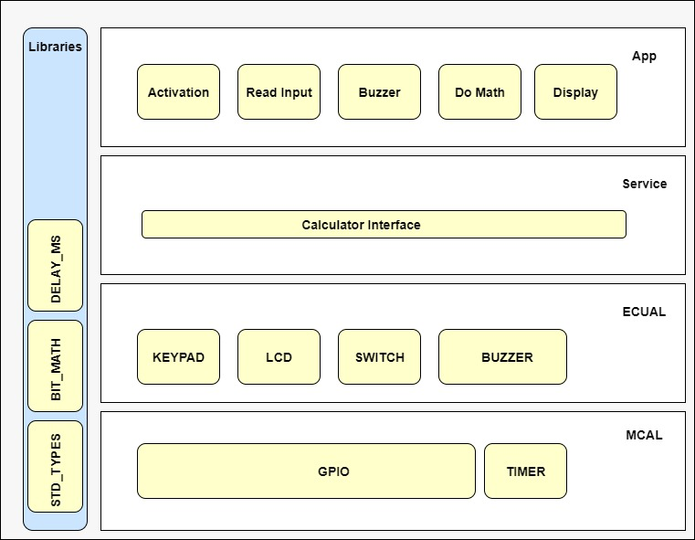

Figure ‑ Project Layered Architecture

# **Components**

Clarifying the components mentioned in the layered architecture, their public API’s, arguments, return value and requirements covered.

## **MCAL API’s**

### **GPIO**

#### GPIO Initiate

|  |  |
| --- | --- |
| Requirement ID | * Req_PO1_DGC_GDD_001_V01 |
| API | errstate GPIO_voidInit (void) |
| Description | This API shall initiate GPIO pins with initial values or configured values if exists |
| Arguments | * void |
| Return | * errstate that holds the error state of the API implementation, it shall be 0 for OK if everything is done correctly, and 1 for NOK if anything goes wrong. |
| Covers | * NA |

#### GPIO Set Pin Mode

|  |  |
| --- | --- |
| Requirement ID | - Req_PO1_DGC_GDD_002_V01 |
| API | errstate GPIO_voidSetPinMode (u8 Copy_u8Pin, u8 Copy_u8Mode) |
| Description | This API shall set pin mode as input or output |
| Arguments | * Copy_u8Pin: specifies pin number, which shall be number in this range: [0-7] * Copy_u8Mode: specifies pin mode, which is 0 for input and 1 for output |
| Return | * errstate that holds the error state of the API implementation, it shall be 0 for OK if everything is done correctly, and 1 for NOK if anything goes wrong. |
| Covers | * Req_PO1_DGC_SRS_032_V01 * Req_PO1_DGC_SRS_033_V01 |

#### GPIO Set Pin Value

|  |  |
| --- | --- |
| Requirement ID | * Req_PO1_DGC_GDD_003_V01 |
| API | errstate GPIO_voidSetPinValue (u8 Copy_u8Pin, u8 Copy_u8Value) |
| Description | This API shall set pin value |
| Arguments | * Copy_u8Pin: specifies pin number, which shall be number in this range: [0-7] * Copy_u8Mode: specifies value set to the pin, which shall be 0 or 1 |
| Return | * errstate that holds the error state of the API implementation, it shall be 0 for OK if everything is done correctly, and 1 for NOK if anything goes wrong. |
| Covers | * NA |

#### GPIO Get Pin Value

|  |  |
| --- | --- |
| Requirement ID | * Req_PO1_DGC_GDD_004_V01 |
| API | errstate GPIO_u8GetPinValue (u8 Copy_u8Pin, u8 * Copy_u8Value) |
| Description | This API shall get pin value |
| Arguments | * Copy_u8Pin: specifies pin number, which shall be number in this range: [0-7] * Copy_u8Value: pointer that holds the value of the pin, it shall be 0 or 1 |
| Return | * errstate that holds the error state of the API implementation, it shall be 0 for OK if everything is done correctly, and 1 for NOK if anything goes wrong. |
| Covers | * NA |

### **Timer**

#### Timer Initiate

|  |  |
| --- | --- |
| Requirement ID | Req_PO1_DGC_GDD_005_V01 |
| API | errstate TIMER_ errstateInit (void) |
| Description | This API shall initiate timer |
| Arguments | * void |
| Return | * errstate that holds the error state of the API implementation, it shall be 0 for OK if everything is done correctly, and 1 for NOK if anything goes wrong. |
| Covers | * NA |

#### Timer Set Callback

|  |  |
| --- | --- |
| Requirement ID | Req_PO1_DGC_GDD_006_V01 |
| API | errstate TIMER_ errstateSetCallback (void(* Copy_PtrCallback)(void)) |
| Description | This API shall set call back function of timer interrupt |
| Arguments | * Copy_PtrCallback: pointer that holds the address of callback function |
| Return | * errstate that holds the error state of the API implementation, it shall be 0 for OK if everything is done correctly, and 1 for NOK if anything goes wrong. |
| Covers | * NA |

#### PWM Start

|  |  |
| --- | --- |
| Requirement ID | Req_PO1_DGC_GDD_007_V01 |
| API | errstate TIMER_ errstatePWMStart (void) |
| Description | This API shall start PWM by setting callback function related to PWM |
| Arguments | * void |
| Return | * errstate that holds the error state of the API implementation, it shall be 0 for OK if everything is done correctly, and 1 for NOK if anything goes wrong. |
| Covers | * NA |

#### PWM Generate Signal

|  |  |
| --- | --- |
| Requirement ID | Req_PO1_DGC_GDD_008_V01 |
| API | errstate TIMER_ errstatePWMGenerateSignal (u16 Copy_OnPeriod, u16 Copy_TotalPeriod) |
| Description | This API shall generate PWM signal by setting its On period, total period and peak value |
| Arguments | * Copy_OnPeriod: specifies the duration of the On part of the period * Copy_TotalPeriod: specifies the duration of the total period |
| Return | * errstate that holds the error state of the API implementation, it shall be 0 for OK if everything is done correctly, and 1 for NOK if anything goes wrong. |
| Covers | * NA |

## **ECUAL API’s**

### **KEYPAD**

#### Keypad Initiate

|  |  |
| --- | --- |
| Requirement ID | Req_PO1_DGC_GDD_009_V01 |
| API | errstate KEYPAD_errstateInit (void) |
| Description | This API shall initiate keypad on its configured pins |
| Arguments | * void |
| Return | * errstate that holds the error state of the API implementation, it shall be 0 for OK if everything is done correctly, and 1 for NOK if anything goes wrong. |
| Covers | * Req_PO1_DGC_SRS_028_V01 * Req_PO1_DGC_SRS_029_V01 |

#### Keypad Get Pressed Key

|  |  |
| --- | --- |
| Requirement ID | Req_PO1_DGC_GDD_010_V01 |
| API | errstate KEYPAD_errstateGetKeyPressed (u8 * Copy_u8PtrKey) |
| Description | This API shall get the keypad pressed key |
| Arguments | * Copy_u8PtrKey: pointer that holds the value of the pressed key |
| Return | * errstate that holds the error state of the API implementation, it shall be 0 for OK if everything is done correctly, and 1 for NOK if anything goes wrong. |
| Covers | * NA |

### **LCD**

#### LCD Initiate

|  |  |
| --- | --- |
| Requirement ID | Req_PO1_DGC_GDD_011_V01 |
| API | errstate LCD_errstateInit (void) |
| Description | This API shall initiate LCD configurations |
| Arguments | * void |
| Return | * errstate that holds the error state of the API implementation, it shall be 0 for OK if everything is done correctly, and 1 for NOK if anything goes wrong. |
| Covers | * Req_PO1_DGC_SRS_026_V01 * Req_PO1_DGC_SRS_027_V01 |

#### LCD Write Data

|  |  |
| --- | --- |
| Requirement ID | Req_PO1_DGC_GDD_012_V01 |
| API | errstate LCD_errstateWriteString (u8 * Copy_u8PtrString) |
| Description | This API shall display string on LCD |
| Arguments | * Copy_u8PtrString: pointer that holds the string value |
| Return | * errstate that holds the error state of the API implementation, it shall be 0 for OK if everything is done correctly, and 1 for NOK if anything goes wrong. |
| Covers | * NA |

#### LCD Write Command

|  |  |
| --- | --- |
| Requirement ID | Req_PO1_DGC_GDD_013_V01 |
| API | errstate LCD_errstateWriteCmd (u8 Copy_u8Cmd) |
| Description | This API shall send command to LCD |
| Arguments | * Copy_ u8Cmd: specifies command to be sent to LCD |
| Return | * errstate that holds the error state of the API implementation, it shall be 0 for OK if everything is done correctly, and 1 for NOK if anything goes wrong. |
| Covers | * NA |

#### LCD Go to Location

|  |  |
| --- | --- |
| Requirement ID | Req_PO1_DGC_GDD_014_V01 |
| API | errstate LCD_errstateGoToLocation (u8 Copy_u8Line, u8 Copy_u8Position) |
| Description | This API shall set LCD cursor at specific line and position |
| Arguments | * Copy_ u8Line: specifies line of the cursor, it shall be 1 or 2 * Copy_ u8Position: specifies position of the cursor in the line, it shall be in the range [0-15] |
| Return | * errstate that holds the error state of the API implementation, it shall be 0 for OK if everything is done correctly, and 1 for NOK if anything goes wrong. |
| Covers | * NA |

#### LCD Clear

|  |  |
| --- | --- |
| Requirement ID | Req_PO1_DGC_GDD_015_V01 |
| API | errstate LCD_errstateClear (void) |
| Description | This API shall clear the display of LCD |
| Arguments | * void |
| Return | * errstate that holds the error state of the API implementation, it shall be 0 for OK if everything is done correctly, and 1 for NOK if anything goes wrong. |
| Covers | * NA |

### **SWITCH**

#### Switch Initiate

|  |  |
| --- | --- |
| Requirement ID | Req_PO1_DGC_GDD_016_V01 |
| API | errstate SWITCH_errstateInit (void) |
| Description | This API shall initiate switch on its configured pins |
| Arguments | * void |
| Return | * errstate that holds the error state of the API implementation, it shall be 0 for OK if everything is done correctly, and 1 for NOK if anything goes wrong. |
| Covers | * Req_PO1_DGC_SRS_031_V01 |

#### Get Switch State

|  |  |
| --- | --- |
| Requirement ID | Req_PO1_DGC_GDD_017_V01 |
| API | errstate SWITCH_errstateGetSwitchState (u8 * Copy_u8PtrSwitchState) |
| Description | This API shall get the switch state |
| Arguments | * Copy_u8PtrSwitchState: pointer that holds the switch state, it shall be 1 if switch is pressed and 0 if switch is released. |
| Return | * errstate that holds the error state of the API implementation, it shall be 0 for OK if everything is done correctly, and 1 for NOK if anything goes wrong. |
| Covers | * NA |

### **BUZZER**

#### Buzzer Initiate

|  |  |
| --- | --- |
| Requirement ID | Req_PO1_DGC_GDD_018_V01 |
| API | errstate BUZZER_errstateInit (void) |
| Description | This API shall initiate buzzer on its configured pins |
| Arguments | * void |
| Return | * errstate that holds the error state of the API implementation, it shall be 0 for OK if everything is done correctly, and 1 for NOK if anything goes wrong. |
| Covers | * Req_PO1_DGC_SRS_030_V01 |

#### Run Buzzer

|  |  |
| --- | --- |
| Requirement ID | Req_PO1_DGC_GDD_019_V01 |
| API | errstate BUZZER_errstateRunBuzzer (u16 Copy_u16Frequency, u8 Copy_u8Duty) |
| Description | This API shall run buzzer for specific frequency in specific duty cycle |
| Arguments | * Copy_u16Frequency: specifies the buzzer frequency, it shall be 250 or 500 Hz * Copy_u8Duty: specifies the percentage of duty cycle |
| Return | * errstate that holds the error state of the API implementation, it shall be 0 for OK if everything is done correctly, and 1 for NOK if anything goes wrong. |
| Covers | * NA |

## **Application API’s**

### **Activation**

#### Calculator Power On

|  |  |
| --- | --- |
| Requirement ID | Req_PO1_DGC_GDD_020_V01 |
| API | errstate CALCULATOR_errstatePowerOn (void) |
| Description | This API shall power the calculator on by turning LCD on and starting to accept input from keypad |
| Arguments | * void |
| Return | * errstate that holds the error state of the API implementation, it shall be 0 for OK if everything is done correctly, and 1 for NOK if anything goes wrong. |
| Covers | * Req_PO1_DGC_SRS_010_V01 |

#### Calculator Power Off

|  |  |
| --- | --- |
| Requirement ID | Req_PO1_DGC_GDD_021_V01 |
| API | errstate CALCULATOR_errstatePowerOff (void) |
| Description | This API shall power the calculator off by turning LCD off and not to accept input from keypad |
| Arguments | * void |
| Return | * errstate that holds the error state of the API implementation, it shall be 0 for OK if everything is done correctly, and 1 for NOK if anything goes wrong. |
| Covers | * Req_PO1_DGC_SRS_011_V01 |

### **Read Input**

#### Keypad Input

|  |  |
| --- | --- |
| Requirement ID | Req_PO1_DGC_GDD_022_V01 |
| API | errstate KEYPAD_errstateReadInput (u8 * Copy_u8PtrKey) |
| Description | This API shall take input from user through keypad buttons |
| Arguments | * Copy_u8PtrKey: pointer that holds the value of the key pressed, it shall be number in the range [0-9] or letter in range [A, B, C, D]; where A represents plus operator, B represents subtract operator, C represents multiplication operator, D represents division operator, or # that represents decimal point, or * that represents clear button. |
| Return | * errstate that holds the error state of the API implementation, it shall be 0 for OK if everything is done correctly, and 1 for NOK if anything goes wrong. |
| Covers | * Req_PO1_DGC_SRS_001_V01 |

### **Buzzer**

#### Run Tone

|  |  |
| --- | --- |
| Requirement ID | Req_PO1_DGC_GDD_023_V01 |
| API | errstate BUZZER_errstateRunTone (u8 Copy_u8Tone) |
| Description | This API shall run buzzer by specific tone |
| Arguments | * Copy_u8Tone: specifies which tone to be run on buzzer, this shall be Tone1 or Tone2. Each tone has specific configurations for duty and frequency. |
| Return | * errstate that holds the error state of the API implementation, it shall be 0 for OK if everything is done correctly, and 1 for NOK if anything goes wrong. |
| Covers | * Req_PO1_DGC_SRS_004_V01 * Req_PO1_DGC_SRS_005_V01 |

### **Do Math**

#### Calculate

|  |  |
| --- | --- |
| Requirement ID | Req_PO1_DGC_GDD_024_V01 |
| API | errstate DOMATH_errstateCalculate (u8 Copy_u8Op1, u8 Copy_u8Op2, u8 Copy_u8Operator, u8 * Copy_u8PtrResult) |
| Description | This API shall take operand 1, operand 2 and operation and calculate the result of the operation. |
| Arguments | * Copy_u8Op1: specifies the value of operand 1 * Copy_u8Op2: specifies the value of operand 2 * Copy_u8Operator: specifies the operator * Copy_u8PtrResult: pointer that holds the value of the result |
| Return | * errstate that holds the error state of the API implementation, it shall be 0 for OK if everything is done correctly, and 1 for NOK if anything goes wrong. |
| Covers | * Req_PO1_DGC_SRS_018_V01 |

### **Display**

#### Display Message

|  |  |
| --- | --- |
| Requirement ID | Req_PO1_DGC_GDD_026_V01 |
| API | errstate DISPLAY_errstateDisplayMsg (u8 Copy_u8Mode, u8 * Copy_u8PtrMsg) |
| Description | This API shall display message on LCD |
| Arguments | * Copy_u8Mode: specifies the mode of the message, it shall be 0 for error message and 1 for result message * Copy_u8 PtrMsg: pointer that holds the string message to be displayed, it shall be error message or result message depending on mode. |
| Return | * errstate that holds the error state of the API implementation, it shall be 0 for OK if everything is done correctly, and 1 for NOK if anything goes wrong. |
| Covers | * Req_PO1_DGC_SRS_007_V01 * Req_PO1_DGC_SRS_008_V01 |

#### Clear Display

|  |  |
| --- | --- |
| Requirement ID | Req_PO1_DGC_GDD_027_V01 |
| API | errstate DISPLAY_errstateClearDisplay (void) |
| Description | This API shall clear display of LCD |
| Arguments | * void |
| Return | * errstate that holds the error state of the API implementation, it shall be 0 for OK if everything is done correctly, and 1 for NOK if anything goes wrong. |
| Covers | * Req_PO1_DGC_SRS_025_V01 |